**BAMA 520 Customer Analytics**

**Group Assignment 3**

**Pilgrim Bank Case**

**Group 17**

Xinyuan Wang

Iris Xing

Zhao Zhang

Robert Zhao

**Contents**

***Introduction 2***

***Model Description 2***

**Decision Variables 3**

**Objective 3**

**Assumptions 7**

1. Neglect the possible different merchandise arrival dates while shipping from Ovis. 7

2. Neglect lead time on the road transportation between major cities for the orders from Domes 8

3. Each store’s demand will be met with exact supply. 8

4. Monthly demand of each store is static. 8

**Constraints 8**

1. Quantities produced by both suppliers together 9

2. Five hundred units must be supplied by Domes 9

3. Total capacity of containers used 9

**Methodology 10**

***Discussion of Analyses and Results 10***

**Optimal Strategy and Recommendations to Oz Sourcing 10**

**Business Insights 12**

**Limitation 12**

***Appendix I 13***

Executive Summary

With the global supply network being rapidly developed, many small and medium companies start to look for opportunities to benefit from both the low cost from the overseas vendors and the flexibility from the local manufactures. Here we have Oz Sourcing as a case to study how to manage the production plans between the overseas and local vendors to minimize cost and achieve higher profits and how various factors influence the optimal solutions.

Integer Programming methodology is used to solve the constraint satisfaction problem faced by OZ Sourcing. It is a subfield of the general topic of mathematical optimization. It guarantees an actionable optimal solution; unless there are conflicts in the constraints that render the problem with no feasible region. The Excel Solver plugin is used to formulate OZ Sourcing’s optimization problem as a linear programming problem with decision variables subject to integer constraints. According to the Solver result, there are feasible solutions to balance supply between Ovis and Domes, and our report provides the details of one of such optimal production plans.

In the real world, the global network supply problems are way more complex. It involves more uncertainties. Here, our model is simplified to provide solutions under certain assumptions. Our results suggest that Oz Sourcing should engage the local supplier, Domes, in order to minimize the current unit and shipment cost. Given the current demand level, Oz Sourcing’s overall unit and transportation cost (under the optimal production and shipment plan) is $2,172,890 with Ovis as its only supplier, and $2,163,893 while engaging Domes. In other words, engaging Domes would result in a 0.414% reduction in the unit and transportation cost for Oz Sourcing.

This report will also provide the client company with practical business insights on allocating future production plans between local suppliers and overseas suppliers. It is recommended that Oz Sourcing should keep overseas vendors as the major source of the inventory while leveraging the local manufactures to fill up demand fluctuation gaps.

# Introduction

Making decisions about logistic plans can be an exhaustive challenge for any business manager in the retail industry. With the current trend of leveraging global supply chains, decision-makers have to take trade-offs between local and overseas suppliers into consideration, which can be fairly complex. Among these, supply cost usually accounts for nearly 30% of total operation cost for the retail industry1. In this report, we build an integer programming optimization model for OZ Sourcing in order to address these challenges. To come up with a more cost-effective production plan, we need to resolve several factors that could interfere with each other. Namely,

* Container capacity related cost
* Transportation cost via various means
* Transportation lead time
* Product unit cost (local vs. globe)
* Demand fluctuation (Seasonality)

Oz Sourcing Limited is a company that sells stereo systems across Australia in five major cities (Adelaide, Brisbane, Melbourne, Perth, and Sydney). Ovis Supply Limited is an overseas stereo system supplier for Oz Sourcing. Products are sea transported to the warehouses in the five cities, but additional road transportation costs might be incurred if Oz Sourcing requires to redirect products from one city to another to accommodate changes in demand. This is sometimes not efficient or cost-effective due to the long lead time and high road transportation cost. To address these issues, Oz Sourcing considers hiring a new local supplier, Domes Manufacturing Systems. Unlike Ovis, Domes can produce products in any major city in Australia, and the unit cost is location-based.

The purpose of this case study is to dissect and understand the different cost components of both suppliers and how the optimal production and transportation plan shift as Domes is introduced into the supply chain. We first compare the overall cost of the Ovis-only network against the Ovis-Domes hybrid network to identify the cost-benefits of introducing Domes. We then break down the cost components of each supplier to understand how different cost components shift as in the optimal production plan. Such information can be then used to inform and assist the managerial decision-making process.

*1Contents. (n.d.). Retrieved February 13, 2021, from* [*https://transportgeography.org/contents/chapter7/logistics-freight-distribution/ecommerce_cost_structure-2/*](https://transportgeography.org/contents/chapter7/logistics-freight-distribution/ecommerce_cost_structure-2/)

# Model Description

## Decision Variables

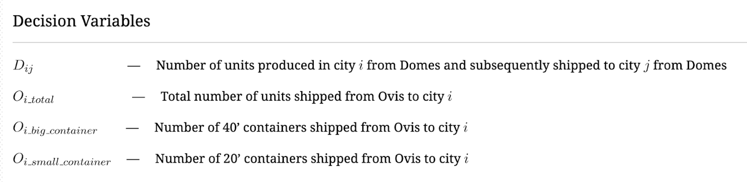

Figure 1: Decision Variables

OZ Sourcing management needs to see the detailed supply plan of stereos units, and thus our decision variables include distribution of supplies coming from Domes and Ovis. In the optimization model, we used two sets of decision variables. The first set contains the decision variables that are related to the production and shipment plan of the local supplier Domes, with D as the variable name prefix. Decision variables that are associated with the overseas supplier Ovis have O as their name prefix. Both sets formulate the OZ Sourcing’s challenge as an integer programming optimization problem.

The variables in figure 1 above are all integer variables. Supplies originating from Ovis are categorized as two integer variables *Oi_big_container* and *Oi_small_container*, to accommodate the two shipping options, for 40’ container and 20’ container respectively:

Oi_big_container represents the integer number of 40’-container used to ship stereos to city i, each holding 200 units of stereo systems.

Oi_ small_container represents the integer number of 20’-container used to ship stereos to city i, each holding 100 units of stereo systems.

Oi_total represents the integer number of total units planned to order from Ovis and deliver to each city i.

## Objective

Our objective is to minimize the total cost at the given level of demand and help Oz Sourcing determine the optimal production and shipment plan.

Total cost in our objective function contains six cost components that cover the expenses incurred by both the suppliers (Ovis and Domes). The six components include Domes Units Cost, Domes Shipment Cost, Ovis Units Cost, Ovis Container Cost, Ovis LCL Cost, and Ovis Inventory Holding (Interest) Cost. Specifically:

Domes unit cost is calculated by the sum of unit costs ordered from each city/(plants). Per-city unit cost is calculated by the total number of units sent from Domes to that city times the city-specific per-unit-cost (given by the client company).

Domes shipment cost is calculated as the sum of all city-pair (Ovis operating city to Domes supplying city) transportation costs. Since there is a Domes supply center in every city of Ovis’ 5 operation centers and products can be shipped within cities, there are 25 city-pair shipment costs in total to be calculated.

Ovis unit cost is calculated as the sum of unit costs shipped to each city. Per-city unit cost is calculated by the total number of units ordered from Ovis to city i times a per-unit-cost of $440, which is invariant among cities.

The Ovis shipment cost has two sub-components: the sum of the total container costs and the sum of less-than-container load (LCL) costs, for each demand location. The container cost for each Ovis-city pair is calculated by multiplying the number of 40’ and 20’ containers used with the per-unit-cost of the respective container size.  LCL cost is calculated by a LCL per-unit-cost times the number of LCL units. Because of loading and safety constraints, containers are required to be fully loaded. But when the number of units is not enough to fill up the entire container, LCL cost will be incurred. LCL units are essentially the empty space of unfilled containers. It is a penalty cost to compensate for the empty-space of unfilled containers, as per safety regulation standards.

Ovis inventory holding(interest) cost is incurred by the shipment lag-time of sea transportation. It is calculated by the total unit cost times the adjusted fixed-period interest rate (i.e., interest rate from 21 days of lag time), which is converted from a 15% annual interest rate given by the accounting department of the client company.

## Assumptions

1.     Neglect lead time on the road transportation between major cities for the orders from Domes.

2.     Neglect the possible different merchandise arrival dates while shipping from Ovis.

3.     Monthly demand of each store is static.

4.     Each store’s demand will be met with exact supply.

5.   Inventory value is the total unit cost of products.

### Neglect the possible different merchandise arrival dates while shipping from Ovis.

The actual sea transportations usually have long shipping lengths and lead times. Considering the distances and weather conditions, companies need to take the risks of the products and goods not being delivered on time. It brings in lots of uncertainties for the inventory management in stores. As described in the case, when it happens, extra costs will be generated for the transportations between stores in order to fulfill the demand and balance the inventories among stores. The assumption here is that based on the known lead time, Oz Sourcing will order the products for each store accordingly so that every store will receive the products on the same day of each month. Therefore, the solver model doesn’t need to include extra inter-city transportation variables.

### Neglect lead time on the road transportation between major cities for the orders from Domes

Compared to the sea transportation from overseas, the shipping time between local city-pairs is relatively short. With an annual interest rate, the money depreciation within these few days doesn’t contribute much to the time value of money. Therefore, the inventory holding cost for orders from Domes by road transportation can be safely ignored in the solver model.

### Each store’s demand will be met with exact supply.

The client company provided very limited information regarding how the stores deal with the inventories. It’s common that the store will have limited space to hold a small amount of each product they sell for a month or two. When the inventory gets overstocked, it’s quite expensive for the stores to find temporary storage space.  Those costs could accumulate up fast and surprisingly affect the profits. Therefore, in this model, it is assumed that each store’s demand will be met with the exact number of products. The variances in the inventory management on the store side can be avoided in this way.

### Monthly demand of each store is static.

The actual monthly demand usually fluctuates in reality. The demand can be affected by many factors, such as seasonality, advertising, competition from other stores. However, it is inferred from the case that each store in the five cities currently has constant demand every month. Combining with assumption 3 mentioned above, the solver model assumes that each store’s monthly demand is static. So that the model can provide an optimal production plan that works month over month.

Assumption 3 and 4 form up an unrealistic situation. It leads to less business-wise meaningful production plans and objective values. These two assumptions will be further discussed in the limitation and the future extensions sections.

## Constraints

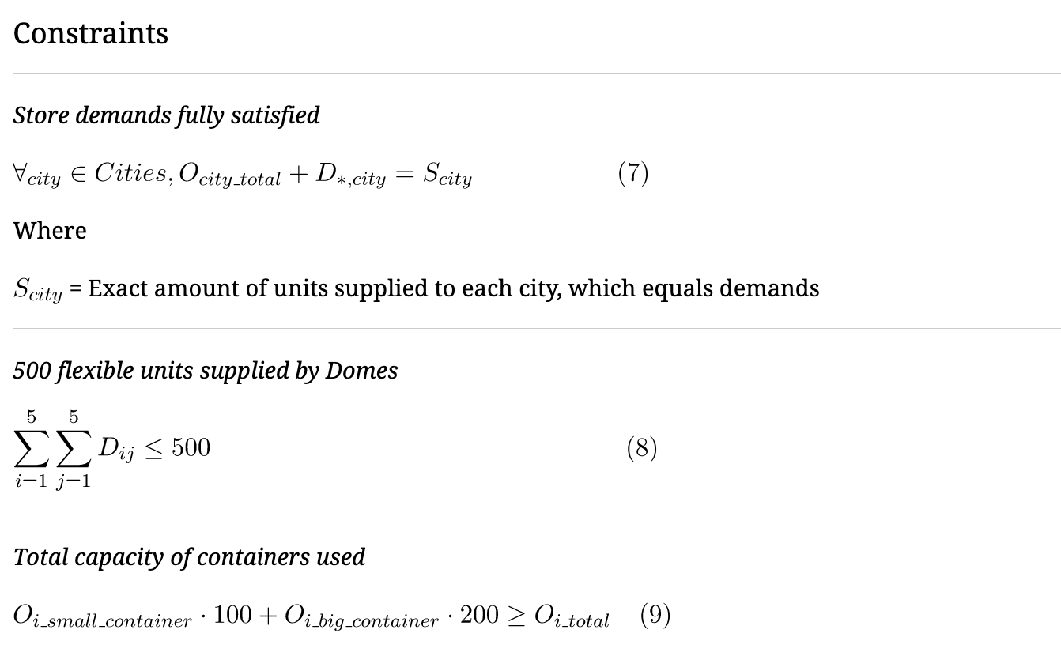

### Quantities produced by both suppliers together

The first constraint sets the number of units to be produced for each store location and ensures that the demand of each store is met. For each store location, the demand is fulfilled by units from either the overseas supplier Ovis or the new supplier Dome. Therefore, the constraint is set up with the sum of units from the two suppliers to assure the second supplier is contributing.

On the other hand, setting the limit equal to the demand ensures that the quantities supplied will not exceed the demand, echoing assumption 3. This constraint is the core of this optimization model. It specifies the demand units and provides a constraint to find the optimal solution.

### Five hundred flexible units supplied by Domes

Oz Sourcing wants to test whether ordering 500 flexible units from Domes is cost beneficial. If so, Oz Sourcing needs to determine the number of flexible units to minimize the total cost. As Oz Sourcing is allowed to choose the locations of manufacturing, the sum of the units produced at each location should be less than or equal to 500. Adding this constraint allows managers to see the difference between the total costs of two different strategies with and without Domes.

### Total capacity of containers used

As Ovis is an overseas supplier, sea transport is used for their shipments and therefore Ovis needs to choose from 40’ containers or 20’ containers, depending on the shipment. A 40’ container can hold 200 units and a 20’ container can hold 100 units. By multiplying the capacity of each container with the respective number of containers, we know the overall total capacity of each shipment.

One thing to note here is that the price of a 40’ container is smaller than two times the price of 20’ containers according to the information provided by Oz Sourcing. We expect the model to prioritize the selection on the 40’ container over the 20’ container to save costs.

As the quantities to order are not guaranteed to be exact hundreds, there will be cases that one of the containers is not fully loaded. As a result, the overall total capacity could be larger than the actual units ordered to ship. Therefore, the constraint sets the number of units produced by Ovis for each city to be smaller than or equal to the overall container capacity.

## Methodology

We use a mathematical optimization method called Integer Programming to solve the problems presented in this case. Given the options provided by Ovis and Domes, the framework of Integer Programming guarantees to find the best integer values of each decision variable to achieve the optimal outcome, and therefore find the combination that minimizes the total costs for OZ sourcing. Decision variables, such as production and transportation plans, can be configured to have integer values; thus, our result would not break a container or unit into pieces.

This framework also allows users to add specific constraints while trying to find the optimal solution to their problems.  For OZ Sourcing, an example of such constraint would be the total number of units produced from Domes cannot exceed 500. It is of vital importance that the constraints create a feasible region for the solver to work.

We use the solver tool in Excel to formulate this case as an integer programming problem and apply the requirements and constraints to our model. Our result suggests that the problem from OZ Sourcing management is feasible to solve. Based on the properties of Integer Programming, we are confident to present the following discoveries with the guarantee of it being the optimal solution to this problem.

# Discussion of Analyses and Results

## Optimal Strategy and Recommendations to Oz Sourcing

Under current assumptions, the result of our optimization model suggests that engaging Domes would be the better option for OZ Sourcing. If all demands were fulfilled directly from Ovis to each city, the total cost, including unit production cost and shipping cost, would be $2,172,890 dollars. In comparison, if stereos were ordered from both Domes and Ovis, the total combined cost was reduced to $2,163,893 dollars, resulting in a 0.414% deduction.

Figure 2. Ovis production and shipment plan (with Ovis as the only supplier)

The optimal production plan indicates that OZ Sourcing should allow Domes to produce 480 units of stereos at Adelaide. Among them, 420 units are kept in the city, 50 units and 10 units were then transported by road to Melbourne and Sydney respectively. Demand from Adelaide was met in full by local production from Domes.

Figure 3. Domes Production Plan (with both suppliers)

Figure 4. Ovis Production and Container Plan (with both suppliers)

Brisbane and Perth receive 100% of their units from Ovis, with four 40' containers and one 20’ container shipped to Brisbane and five 40' containers shipped to Perth. Unfortunately, those containers were not fully loaded and thus incurred LCL penalty. However, this is still the best production and shipment plan in terms of minimizing the total combined cost for OZ Sourcing to supply stores with exact demand.

Comparing the production plans with and without Domes, the model tries to avoid some sea transportation costs with LCL penalty by shipping as many fully loaded containers as possible.  Specifically, the total demands of the Melbourne store and the Sydney store are 1250 units and 1310 units respectively. In order to avoid LCL penalty costs, 50 units of Melbourne’s demand and 10 units of Sydney’s demand are shifted to Domes for manufacturing. Engaging Domes enables Ovis to ship fully loaded containers to achieve maximum efficiency since residual units could be supplied by Domes with road transportation.

## Business Insights

When demand is stable, Oz Sourcing should place fixed monthly shipment orders for each store from the overseas supplier Ovis and take advantage of its lower costs. The risk here is the long lead time of sea transportation brings in lots of uncertainties. Therefore, the order with the overseas supplier should be planned ahead and only needs to meet basic and regular demand. On the other hand, the additional charges of Less Container Load is also a major contributor to the cost of ordering from overseas. As concluded above, the number of units should be integer/in 100s to load the containers as fully as possible so that additional Less Container Load charges can be minimized. The units left out that can’t be loaded as a full container could be manufactured by the local vendors like Domes.

When there are demand fluctuations, it is recommended to keep the original production plan with Ovis and order the surging units from the local supplier. Although the unit cost is higher than Ovis’s, the local road transportation is more reliable and predictable. Additionally, the fluctuations in demand are sometimes unpredictable. When there was a gap between demand and inventory, it was hard to backfill the products timely. When Domes was not engaged, the average lead time by ordering overseas was 24 days. Oz Sourcing might either store more units at its warehouse to meet changes in demand, which increases its inventory holding costs; or forgo the additional demand, which decreases its revenue. Engaging Domes allows Oz Sourcing to be able to capture more customers who might need to be forgone. Therefore, with the service from local supplier Domes, Oz Sourcing can expect an obvious increase in its revenue, especially during popular seasons.

Overall, one principle to follow while thinking about the production plan distributions is that the overseas vendors are the major source of the inventory, and the local manufactures are leveraged to fill up the small number of demand fluctuation gaps.

## Limitation

In the real world, the global network supply problems are way more complex than the current model mentioned in this case above. Considering the lead time of the transportations only, it could be another scheduling problem to optimize.

A major limitation is that the model doesn’t capture the demand variance. Each store’s demand won’t be the same in each month. The fixed monthly production plan will bring in more uncertainties for inventory management. Besides, the sales of small electronic applications like stereo systems tend to follow a seasonal fluctuation. Stores should consider stocking up one month or two months earlier depending on the lead time and other factors.

Optimization models, after all, are simply abstractions of real-world scenarios. It is neither realistic nor efficient to formulate models that depict the reality as closely as possible; instead, the goal here is to generate optimal production and transportation policy with the given store demand and generate meaningful managerial insight.

Appendix I

Solver Model Set-up and Optimal Solution when Oz Sourcing engages both Ovis and Domes

Part B: Domes Production and Shipment Plan

Appendix II: Solver Model Set-up and Results when Oz Sourcing engages Ovis only.

